

**Panik** – Daughter

**Najak** – Sister

**Najâtsuk** – Younger sister than yourself to a boy

**Angajuk** – Older Sister

**Nukak** – Younger sister of the same sex

**Nuak** – Niece

**Ujuguk** – Niece on father’s side



**Innik** – Son

**Angajuk** – Older brother

**Nukak** – Younger brother of the same sex

**Nuak** – Nephew

**Ujuguk** – Nephew on father’s side



**Anânak** – Mother

**Annak** – Wife



**Atâtak** – Father

**Angutik** – Husband



**Atâtsiak** – Grandfather

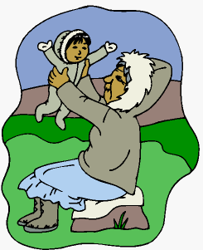

**Anânsiak** – Grandmother on mother’s side

**Ânak** – Grandmother on father’s side



**Ingutak** - Grandchild

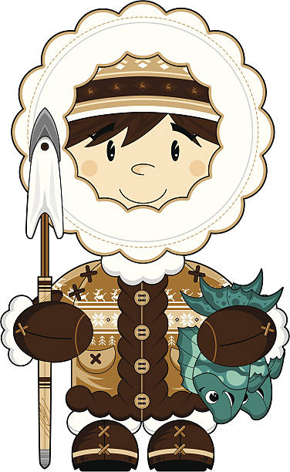

**Angak/Angâtsuk**– Uncle on Mother’s side

**Akkak/Akkâsuk** – Uncle on Father’s side



**Ajak/Ajâtsuk** – Aunt on mother’s side

**Atsak/Atsâsuk**– Aunt on father’s side



**Ningauk/Ningaugâtsuk** – son-in-law, brother-in-law

**Ningaunguak** – step son-in- law, step brother-in-law



**Ukuak/Ukuagâtsuk** – Daughter-in-law, Sister-in-law

**Ukuanguak** - step daughter-in- law, step sister-in-law



**Katangutik/Katangutiatsuk** – Cousin

**Ilak** - Relative