**Silaluk- Rain**

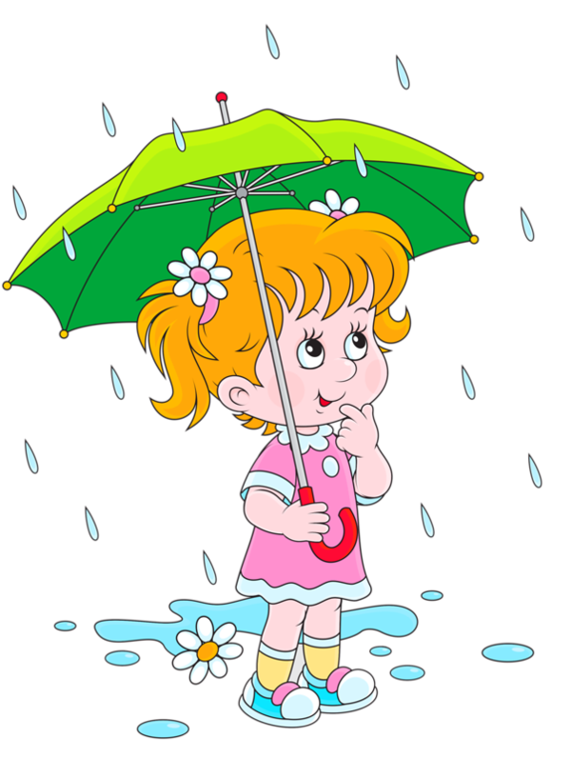

**kalluk- Thunder**

**Kaummalâk - Lightening**

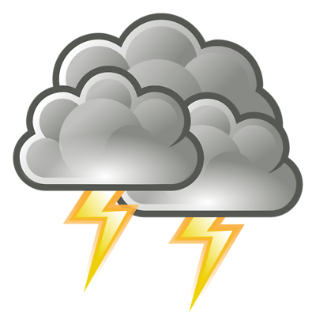

**Kannik- Snow**



**Anugik- Wind**

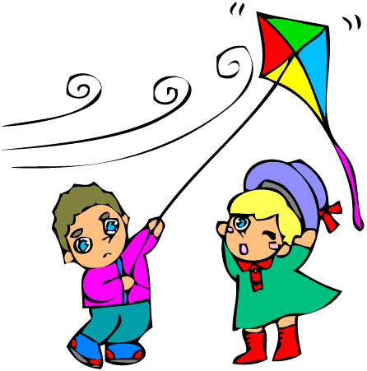

**SiKinigâk-**

**Sun shining**

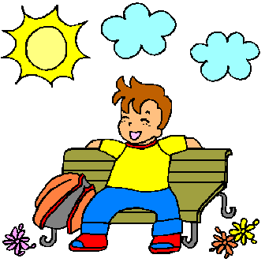

**Nuvujak – Cloud**

